
DEPARTMENT OF EDUCATION
U.T. OF. LAKSHADWEEP
State Annual School Performance Assessment 2024 - 25
Cool off Time: 15 minutes
Class: 5
CBSE
Time: 2 hours
ENGLISH Max. Score: 40
__________________________________________________________________________________________________

General Instructions:
- Write your roll number and name in the space provided.
- Read all the questions carefully before answering.
- Write your answers neatly and legibly in the space provided.
- Attempt all questions. Marks are indicated against each question.
- For multiple-choice questions, circle or put tick mark the correct option.
- For fill-in-the-blank questions, write only the answer in the blank space.
- Do not use any unfair means during the examination.
_____________________________________________________________________________________________

Roll Number:

Name:

Choose the correct answer from the options given.
- If the instruction is "Pass the ball to your teammate,"
what action should you take? (Score:1)

a) Hold the ball
  - Pass the ball to another player on your team
  - Run with the ball
  - Throw the ball away

- Identify the proper noun in the sentence: (Score:1)

- Aysha visited the Taj Mahal during her vacation.
  - Aysha
  - visited
  - vacation
  - during

- Carefully read the dictionary extract given below. (Score: 1)
Swiftly (adverb) – At a fast speed; quickly.
Example: The river flowed swiftly after the heavy rains.
- The word swiftly is an example of which part of speech?
    - Adverb
    - Noun
    - Verb
    - Adjective

- Analyse the sentence and choose the adverb that indicates time: (Score: 1)
  - Neenah visited her grandma yesterday.
    - Visited
    - Yesterday
    - Grandma
    - Her

- Differentiate between the verb tense in the following sentences: (Score: 1)

i) She writes stories.
ii) She wrote a story yesterday.

What is the tense of the verbs writes and wrote respectively?
  - Simple past, simple present
  - Simple present, simple past
  - Present continuous, past perfect
  - Past continuous, present perfect
Fill in the blanks suitably.
- Identify the nouns in this sentence. (Score:1)
- The cat is sitting on the mat.
Ans: ________________ _________________
- Rewrite the sentence by adding an appropriate adverb to describe how the
action is performed: (Score:1)
- The artist painted the portrait _______________________.
- This is from William Blake’s "Night" and strikes a balance between simplicity and literary beauty. Read the lines of the poem and write a suitable rhyming word to complete the line. (use the jumped word in the bracket). (Score:1)

"The sun descending in the west
The evening star does shine
The birds are silent in their ___________ ( ents)
And I must seek for mine.

Write whether the statements are TRUE or FALSE.

- Shouting and fighting each other in your class in the absence of your teacher is a bad habit.

Ans: _____ (Score:1)
- Reading story books from the reading corner in the classroom is a bad habit.
Ans: _______ (Score:1)

Write the answers as directed in full sentences.

- Rewrite the sentence with correct punctuation. (Score:1)

• afra will come to kavaratti island in the month of june
_____________________________________________________________
- Re arrange the jumbled words into a meaningful sentence. (Score:1)

• you / late / ? / are / why / today
Ans: __________________________________________________________
- Convert these sentences from simple present to simple past: (Score 1)

• We eat dinner at 7 p.m.
Ans: _____________________________________________________________

- Fill in the blanks with the antonym of the underlined word and frame
a sentence with it. (Score: 1)
    - The movie was interesting, but the book was reading _______________.
    - Write the sentence here:
__________________________________________________________________________________

Write the answers as directed in full sentences.
- You are Fazil, a student. You have a newly appointed science teacher in your school.

- Write a dialogue between the Fazil and teacher (Score: 2)

Fazil : ___________________________________________________________________
Teacher : __________________________________________________________________
Fazil : ___________________________________________________________________
Teacher : ___________________________________________________________________

16. Read the picture carefully and answer the questions that follows. (Score:2)

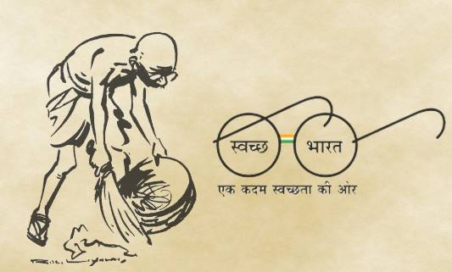
- What does the poster say?
Ans: ___________________________________________________________________________

- Why do you think Mahatma Gandhi is shown cleaning in the poster?
Ans __________________________________________________________________________
__________________________________________________________________________

- Suppose you have given a homework in maths on page 45 of the test.

Write a text message to your friend about the homework. (Score: 2)

Ans: ______________________________________________________________________________
______________________________________________________________________________
- Frame two questions choosing any two pictures given below. (Score:2)

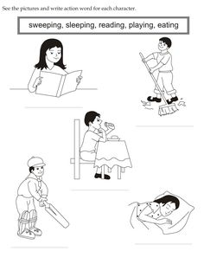
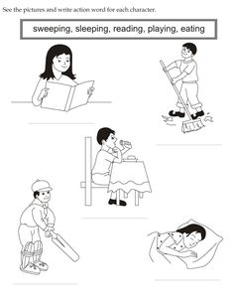

Neena
Nihal
Kevin
Babu

- _______________________________________________________
- _______________________________________________________

Read the story carefully.
The Clever Little Sparrow
Once upon a time in a small forest, there lived a clever little sparrow named Chirpy. Chirpy loved exploring the woods and observing all the animals. One day, while hopping near a river, she saw a big, thirsty crow struggling to reach the water at the bottom of a narrow pitcher.
Chirpy flew closer and asked, "What’s the matter, Mr. Crow?"
“I’m thirsty, but I can’t reach the water in this pitcher,” the crow replied, looking frustrated.
Chirpy thought for a moment and then said, “Don’t worry! I’ll help you.” She looked around and saw some small pebbles nearby. Chirpy picked up a pebble with her tiny beak and dropped it into the pitcher. Then she picked another pebble and dropped it in.
The crow watched curiously. Slowly, as more pebbles went into the pitcher, the water level began to rise. Soon, the crow could reach the water and drank happily.
“Thank you, Chirpy,” said the crow, smiling. “Your clever idea saved me!”
Chirpy replied, “We all need to help each other when we can. That’s what friends are for!”
From that day on, Chirpy and the crow became good friends, always ready to help one another
- Answer the following questions in full sentences. (Score:3)
- What problem did the crow face in the story?
Ans: _______________________________________________________________________________
- How did Chirpy help the crow?
Ans: _____________________________________________________________________________

- Imagine you were Chirpy. Can you think of another way to help the crow drink
water? How would your solution work?

Ans: ___________________________________________________________________________

___________________________________________________________________________

___________________________________________________________________________

- Write an invitation letter to your friend inviting him/her to your birthday party.
(Score: 3)

____________________________________
____________________________________
____________________________________
____________________________________
____________________________________________________________________________________________________________
____________________________________________________________________________________________________________
____________________________________________________________________________________________________________
____________________________________________________________________________________________________________
____________________________________________________________________________________________________________
_________________________________________
_________________________________________
21. Read the Article (1) of the Universal Declaration of Human Rights (UDHR).
Article (1)
All human beings are born free and equal in dignity and rights. They are endowed with reason and conscience and should act towards one another in a spirit of brotherhood.
- Write a short paragraph on the topic given below with your personnel views.

‘Peace, Equality, and the World We Share’

Ans: ______________________________________________________________________________
______________________________________________________________________________

______________________________________________________________________________
______________________________________________________________________________

______________________________________________________________________________

______________________________________________________________________________ ______________________________________________________________________________

- In this picture, the artist is describing a scene. Can you tell me what emotions or
feelings the artist is trying to convey through their description of this scene?
Write a short description not less than 50 words. (Score: 3)

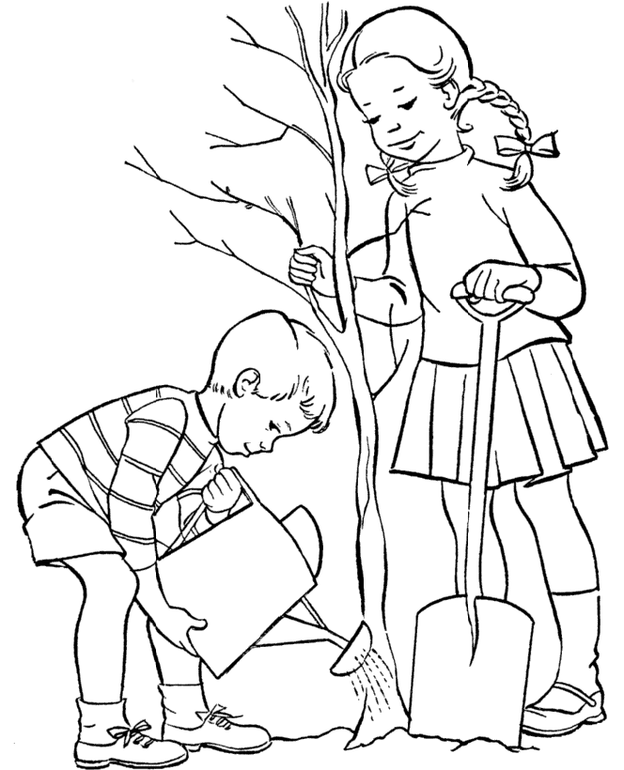
Ans: ______________________________________________________________________________________________
______________________________________________________________________________________________
_____________________________________________________________________________________________
______________________________________________________________________________________________
______________________________________________________________________________________________
_____________________________________________________________________________________________
- Write a paragraph about your school Children’s Day Celebrations using
the following Clues. (Score: 3)

    - Clues: Cultural program, Chief guest, performances, speeches, prizes
    - Use linkers like, and, but, because, then
Ans: ___________________________________________________________________
___________________________________________________________________
__________________________________________________________________
___________________________________________________________________
___________________________________________________________________
_________________________________________________________________

- Study the given map carefully and the questions that follows.
Write the answers in full sentences. (Score: 3)
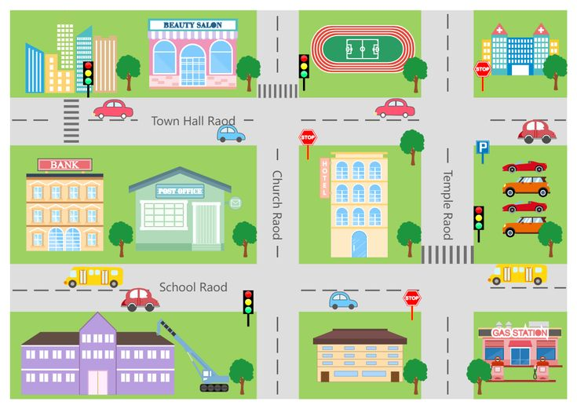

- What is the name of the road that runs between the Bank and the Post Office?
Ans: ______________________________________________________________________________________
- If you were to walk from the School to the Beauty Salon, which direction would you need to walk first?
Ans: _____________________________________________________________________________________
- What building is located at the intersection of Town Hall Road and Church Road?
Ans: _____________________________________________________________________________________

&&&&&&&&&&&

